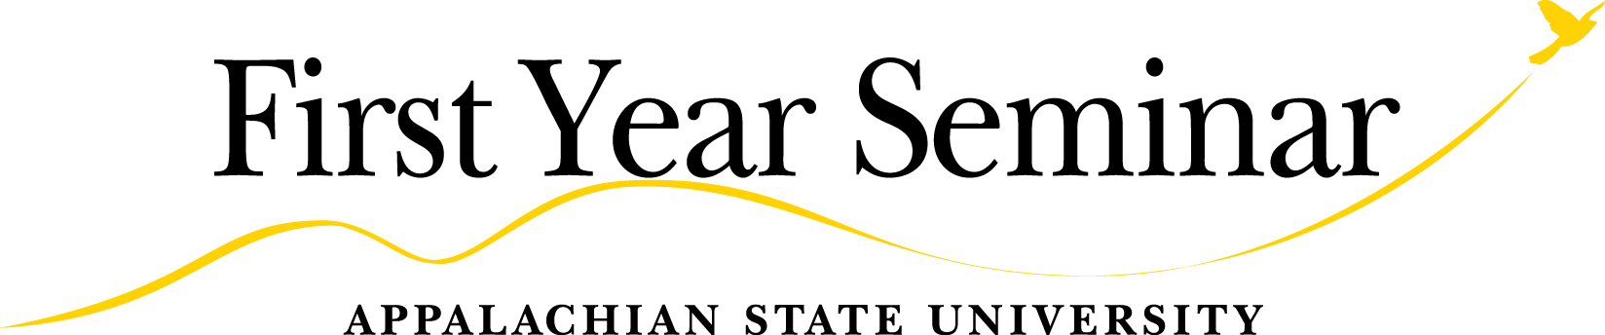

Ten Common Goals of All First Year Seminar Courses

Each FYS course is unique and based on a topic in which the instructor has expertise and is passionate about teaching. But through their unique topic, each FYS instructor designs a course with either assignments or activities intentionally designed to align with the following ten goals.

GOALS OF EXPOSURE
The Goals of Exposure are goals of the First Year Seminar that require activities but not necessarily graded assignments.

- Goal: Expose Students to Appropriate Campus Resources that Help Students Actively Engage in Meaningful Activities throughout College
Evidence of Success: Students will be able to name and know how to locate campus resources such as the Writing Center, Student Learning Center, and library resources, as well as identify opportunities for involvement such as co-curricular activities, service learning, and clubs and organizations.

- Goal: Expose Students to Explicit Expectations for College-Level Work and Support for How to Meet the Level of Challenge
Evidence of Success: Students will: grasp the amount of time and effort inside and outside of class required for success in college; explore a topic that increases awareness and little-known information indicating intense interest and curiosity; complete required work on deadline; pursue opportunities to expand knowledge and skills; pursue educational interests independently outside classroom and basic requirements; make explicit references to previous learning and apply new knowledge to demonstrate comprehension; review prior learning to reveal significantly changed perspectives about education and life experience.

- Goal: Expose Students to the Purpose of a Liberal Education and College
Evidence of Success: Students will embrace their General Education requirements as designed to: prepare them for complexity, diversity, and change; provide them with knowledge of the wider world; cultivate their intellect, imagination, and holistic development; and provide them with transferable skills such as effective communication, critical and creative thinking, making local-to-global connections, and understanding responsibilities of community membership. Put another way, students will understand that the University has economic, civic, and well-being cases for providing them with a General Education.

- Goal: Engage the Year’s Selected Common Reading Book
Evidence of Success: Students will: show appreciation of the authorial and/or the creative process; engage with the common reading book critically and begin to build topical and global knowledge based on the text; and/or practice, in discussing the book, civil discourse in a dissensual community of learners.

- Goal: Expose Students to the General Education Goal of Understanding Responsibilities of Community Membership
Evidence of Success: Students will identify relationships between governments, economies, or societies; identify one’s own participation in civic life; and/or describe civil discourse in dissensual communities.

- Goal: Expose Students to the General Education Goal of Making Local-to-Global Connections
Evidence of Success: Students will develop awareness of the importance of learning: how human agency is affecting humanity, the natural world, and/or the environment; the effects of global change on humanity, nature, and/or the physical environment; various relationships between local regions and people and larger global issues, processes, trends, and/or systems; sustainability in reference to community development, interactions with the natural world, and/or global change; contemporary issues related to cultural diversity in the US and other areas of the world; issues concerning effective communication with people of other cultures, their worldviews, and their frames of reference.

GOALS OF PRACTICE, with COURSE-EMBEDDED ASSESSMENT
The Goals of Practice require not only activities but also structured assignments to give students both opportunities to develop the skills and meaningful feedback from their instructor.

- Goal: Practice Thinking Critically and Creatively (per General Education goal)
Student Learning Outcome (SLO): Students will show some evidence of the following skills: generates questions based on previous information; allows for alternate and/or multiple possibilities; reasoning follows ordered, coherent sequence; identifies, gathers, evaluates, sifts, and organizes information (data, research findings, ideas, etc.); approaches problems utilizing novel ideas, processes, or types of evaluation; relies on appropriate evidence, ideas, logic, methodologies, etc., to make supported findings and conclusions; and relates multiple ideas, observations, or phenomena and/or develops hypothesis and uses empirically derived evidence to address a problem or issue.

- Goal: Practice Communicating Effectively (per General Education goal)
Student Learning Outcome (SLO): Students will show some evidence of the following skills: identifies the simple aim of the message; states the purpose of the message; identifies aspects of the audience; Identifies information sources used; demonstrates awareness of diverse viewpoints; uses relevant criteria to analyze context and situation; identifies preliminary criteria to evaluate and select sources; demonstrates reflection on, and interpretation of, information; demonstrates awareness of the scope of information; shows awareness of assumptions; organizes concepts; shows integration and development of content; creates message that follows a general organizational pattern; creates message that reflects awareness of the purpose and audience with adaptation of approach and tone to them; selects mode of communication that is appropriate for the purpose and audience; presents the message follows primary or major conventions of the discipline, including mechanics and documentation; and generally maintains audience engagement.

- Goal: Practice Examining a Single Issue from Multiple Perspectives to Cultivate Intercultural Competence (per University QEP’s “GLO” goal)
Student Learning Outcome (SLO): Students recognize the importance and validity of others’ perspectives and/or provide culturally grounded evidence to make points (e.g., recognize the cultural underpinning of evidence, opinion, and arguments)

- Goal: Practice the Acquisition of Information Literacy Competencies (in coordination with the required FYS Online Library Component provided by University Library)
Student Learning Outcomes (SLOs): Students will be able to: (1) use multiple information sources in order to investigate a research topic; (2) identify search strategies in order to identify and locate information sources; (3) identify criteria/characteristics for authority in order to determine the credibility of sources; and (4) demonstrate proper attribution and citation in order to give credit and/or acknowledge the original ideas of others.

